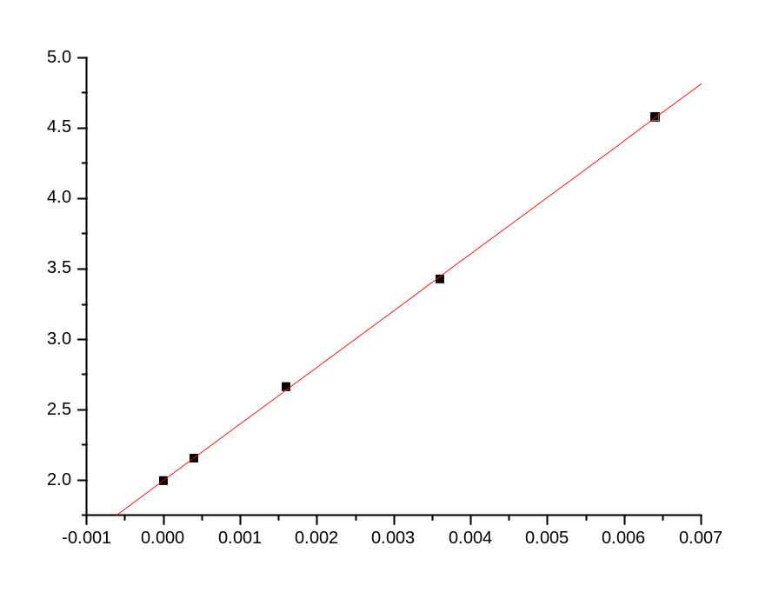[2008-11-28 21:20 "/Graph1" (2454798)]
Linear Regression for Data1_B:
Y = A + B * X

Parameter Value Error
-----------------------------------------
A 1.99883 0.01097
B 402.15517 3.2583
-----------------------------------------

R SD N P
------------------------------------------
0.9999 0.01719 5 <0.0001
------------------------------------------

